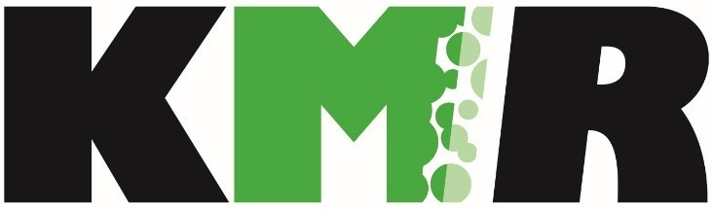

Hiring someone to clean your roof? Here’s what to look for:

⌂ LICENSED, BONDED & INSURED – for your protection, make sure who you hire is following all state regulations. Check with Washington State Labor and Industries to insure all is upfront and honest with the company you hire. For your liability as a homeowner, are their workers and/or sub-contractors covered with Workers’ Compensation insurance? Go to: lni.wa.gov to check out their account.

⌂ SAFETY – ask how the technicians will insure their safety while on your roof. Washington State Labor & Industries requires a safety assessment (Fall Protection Work Plan - WAC 296-155-24611) of each property where work is done.

⌂ ONSITE ESTIMATE – does someone actually come out to the property to measure and assess your roof? Doing measurements on internet satellite imagery is insufficient for ensuring the most accurate bid and best results possible for the services you request.

⌂ ASK ABOUT THEIR CLEANING PROCESSES -- NO pressure washing should ever be done on asphalt/composite shingle or cement tile roofs, as this will significantly age your roof. Even
“brooming” will remove the grit from the face of an asphalt shingle, exposing it to the elements.

⌂ MOSS PREVENTION – after cleaning, what does the company/individual do to prevent the moss from returning? If they have a treatment, is it safe for you, your pets and the environment?

⌂ WARRANTY – do they guarantee their work? For how long?

⌂ REVIEWS, TESTIMONIALS – check reviews online, check with your friends and neighbors. Would they recommend the company you’re seeking to hire?

Make sure you do your “home”work to insure you are getting the best services possible to protect and care for your home!

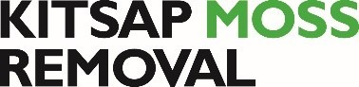
5594 NE Minder Road, #B101, Poulsbo, WA 98370 206-855-5608 360-633-3789
info@kitsapmoss.com www.facebook.com/KitsapMossRemoval/

